Vivahsure
- Dashboard should display all collection data as an analysis view, not as a menu bar.
(FYI)
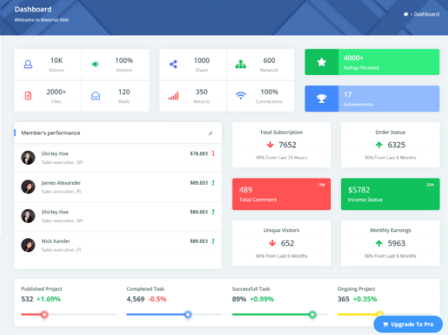
- Add back Navigation button to all the pages on the top.

- If details is present in grid then why we need details fields.
FYI(In details cancel button is not working)
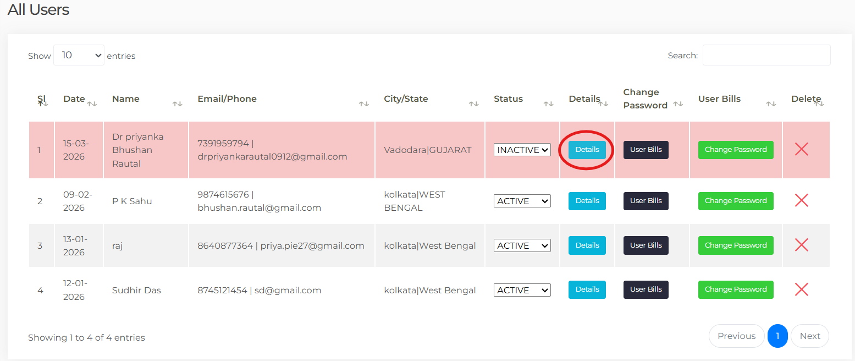

- We need Download button to download a user active or non-active list and also add to respective grids.

- In Edit Password even we don’t edit anything still update is working successfully.
FYI
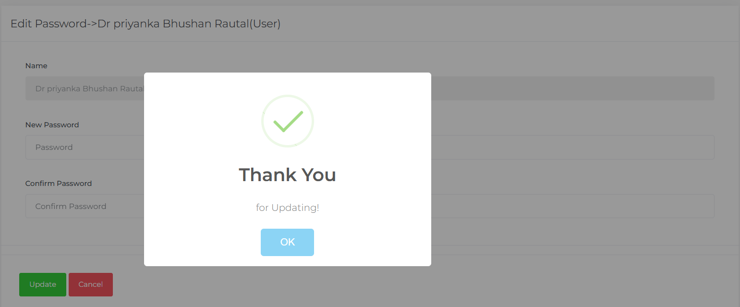

- In users grid we need Action Column like edit,
delete and view and Advanced Filter Bar on the right side.


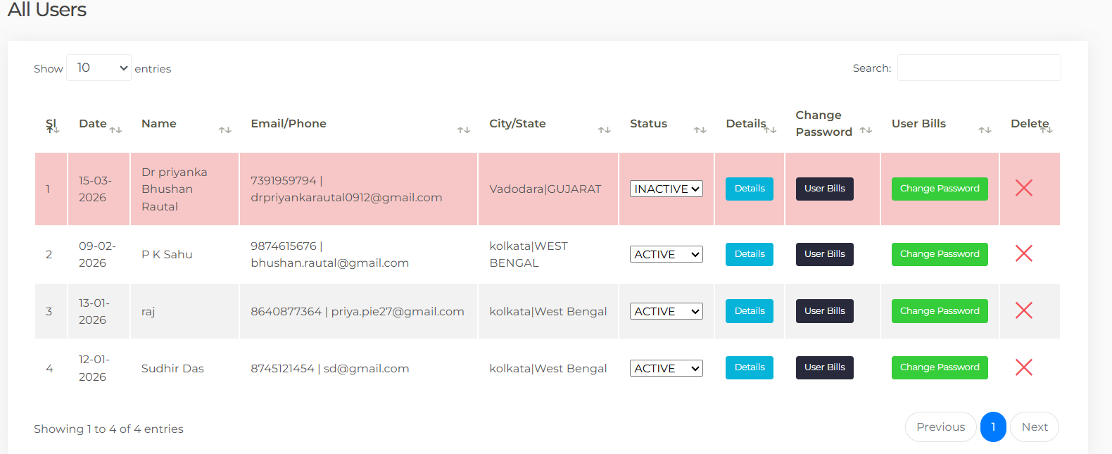

- Even status should be as below.
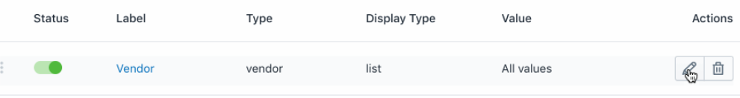
- Login should be role specific.
Software flow: -
(If Agent)

Agent
Initiated
The agent initiates the process by collecting basic details of the bride and groom, such as full name, mobile number, email ID, and photograph. A link will then be shared with them via their registered email ID and mobile number.
(If user login) 
Bride and Groom

Declaration and Authorization

Candidate Declaration Forms

ProfileStatus

9) User profile:-
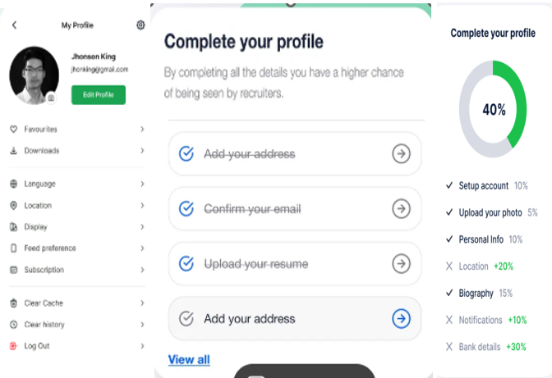

- Add a verification progress field at the bottom left side.
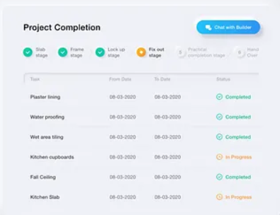

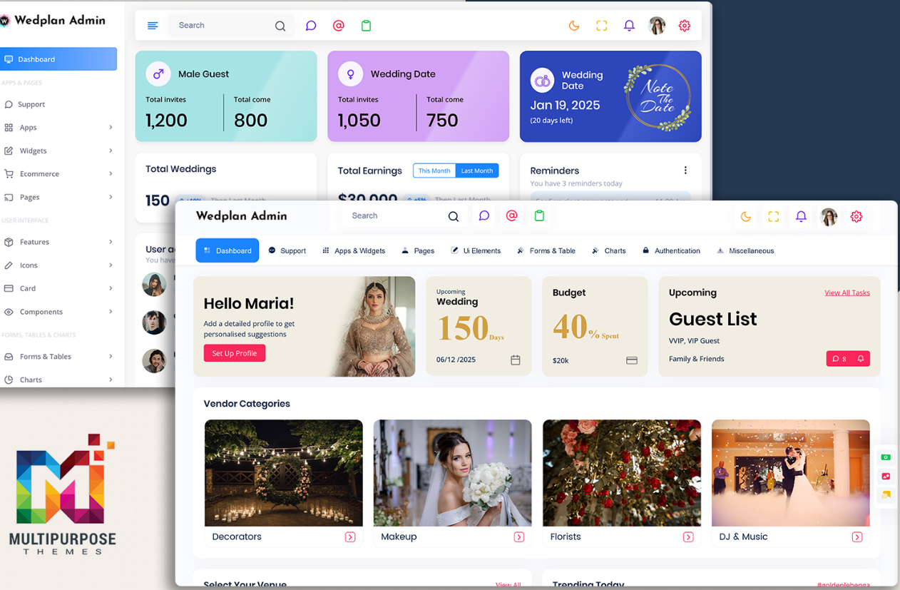
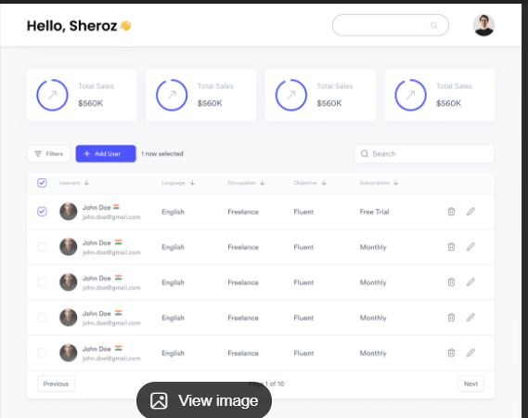

Core KPIs
- Total Registrations
- State wise Registrations
- Pending Verification
- Verified Profiles
- Inactive Profiles
- Active Profiles
Package Overview
- 🥇 Gold Package Users
- 🥈 Silver Package Users
- 🥉 Bronze Package Users
- 💰 Total Revenue (from packages)
Activity / Performance
- Today’s Registrations
- Profiles Verified Today
- Verification Success Rate (%)
- Average Verification Time

- Agent Menu: -
1) Initiated From
The agent initiates the process by collecting basic details of the bride and groom, such as full name, mobile number, email ID, and photograph. A link will then be shared with them via their registered email ID and mobile number.
2) Application Status
In that Agent will check the Application status. Resend application links
Send reminders for incomplete applications or missing documents
View communication history (SMS/email sent logs).

3) Reports & Dashboard
Agent dashboard showing:
  - Total applications created
  - Applications by status
  - Pending actions
Download basic reports (daily/weekly/monthly).
4) Support & Escalation
- Raise support tickets for:
  - System issues
  - Application discrepancies
- Track resolution status of raised issues.
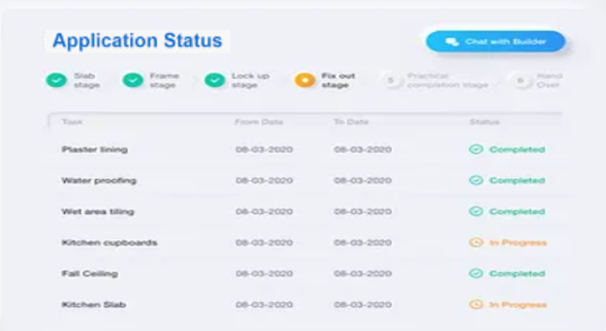
- In admin panel add in menu
Audit & Compliance (Recommended)
- System logs:
- Agent login/logout
- User logs login/logout
- Add Vendor same as users and Agent
- Vendor logs login/logout

Email body which Agent share to users
Dear [User Name],
Greetings from VivahSure!
We are delighted to welcome you to our trusted matrimonial platform, where we help individuals find meaningful and lifelong relationships.
As discussed by our representative, we have initiated your profile creation. To complete your registration and begin your journey with us, please click on the link below:
👉 Register Here: [Insert Registration Link]
For help, feel free to contact us anytime.
– Team VivahSure
Connecting Hearts, Creating Futures ❤️
Package designs
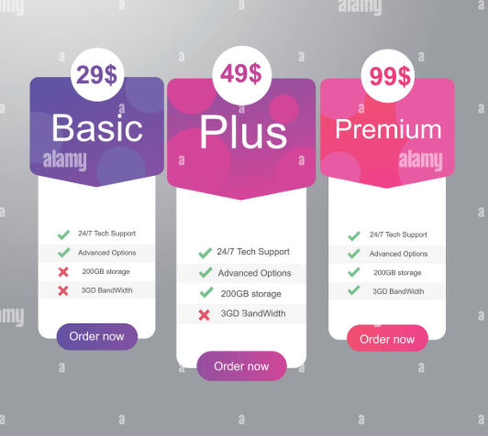
Field Structure for Development.
Step 1 – Basic Applicant Information (mandatory)
• User enters Aadhaar number
• OTP sent to Aadhaar-linked mobile
• User enters OTP
• Verification happens

Fields:
What Data You Get After Verification
Only after OTP + API:
☑ I consent to Aadhaar verification
- ✅ Full Name
- ✅ Date of Birth
- ✅ Gender
- ✅ Address
- ✅ Photo (optional)
Nationality (text)

Step 2 – Identity Verification (mandatory)
PAN Number (Fetch) (Must – File Upload)
Aadhaar Number (Fetch) (Must – File Upload / Front & Back)

Step 3 – Marital Status
Marital Status (radio)
- Never Married
- Divorced
- Widowed
Conditional fields if Divorced/Widowed:
Former Spouse Name
Year of Marriage
Year of Divorce/Separation
Divorce Decree Upload

Step 4 – Employment Details (mandatory)
Employer / Business Name
Job Title / Profession
Employment Type
- Salaried
  - Latest Pay Slip (not older than last 3 months)
  - Form 16
  - Latest ITR
  - UAN Number
- Business Owner
  - Latest ITR
  - GST Number
  - Others
- Self Employed
  - Latest ITR
  - Others
City of Workplace / Business
Income Range (radio)
- Below ₹5 Lakh / Anum
- ₹5 – ₹10 Lakh / Anum
- ₹10 – ₹25 Lakh / Anum
- ₹25 Lakh+ / Anum

Step 5 – Education Details (mandatory)
Highest Qualification
Course / Degree
University / Institution
Year of Completion
Institution City/Country
Degree Upload (file)

Step 6 – Family Information
Father Name
Father Occupation
Mother Name
Mother Occupation
City of Family Residence
Number of Siblings

Step 7 – Lifestyle Information (optional)
Smoking
- Yes
- No
Alcohol
- Yes
- No
- Occasionally
Diet Preference
- Vegetarian
- Non-Vegetarian
- Vegan

Step 8 – Address Information
Residential Address (option to select as per Aadhar – so that address can be auto filled)
City
State
Pin Code
Address Proof Upload

9. Social Media Profiles
LinkedIn: (copy & paste link option for accuracy)
Instagram: (copy & paste link option for accuracy)
Facebook: (copy & paste link option for accuracy)
Other:

Step 10 – 2 Reference Contact (family and friend / office colleague)
Name
Relationship
Phone Number
City
Name
Relationship
Phone Number
City

02-08-26

====================================================================
1) . Login Page
- The login page should be designed similar to the reference image.
- It should include:
  - Sign in with Google (Google Authentication)
  - Email and Password login
  - Forgot Password option
  - Sign Up / Create Account option for new users
  - Remember Me checkbox (optional)
  - Show/Hide Password toggle
  - A clean, modern, and responsive UI suitable for desktop and mobile devices.
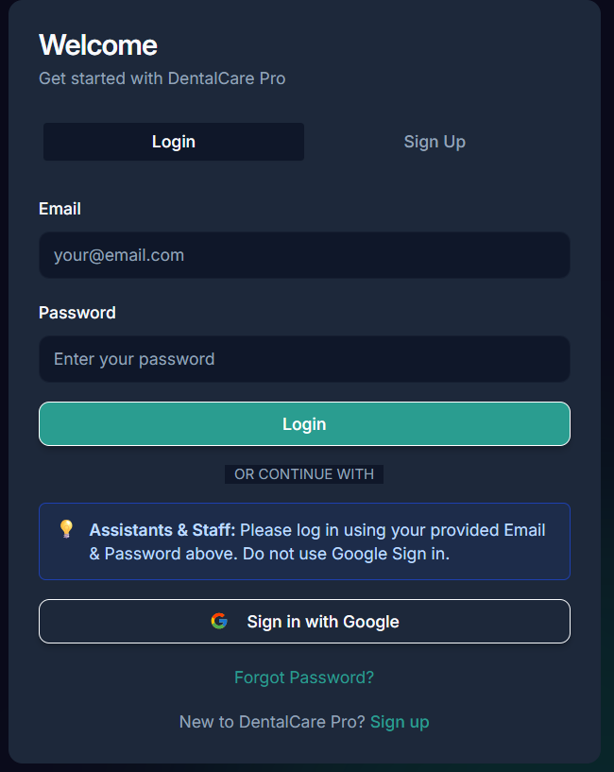
2) Theme Toggle or Appearance Toggle in user login
It represents switching between:
- ☀️ Light Mode
- 🌙 Dark Mode
- Like 

3) In service we need comparison of package like
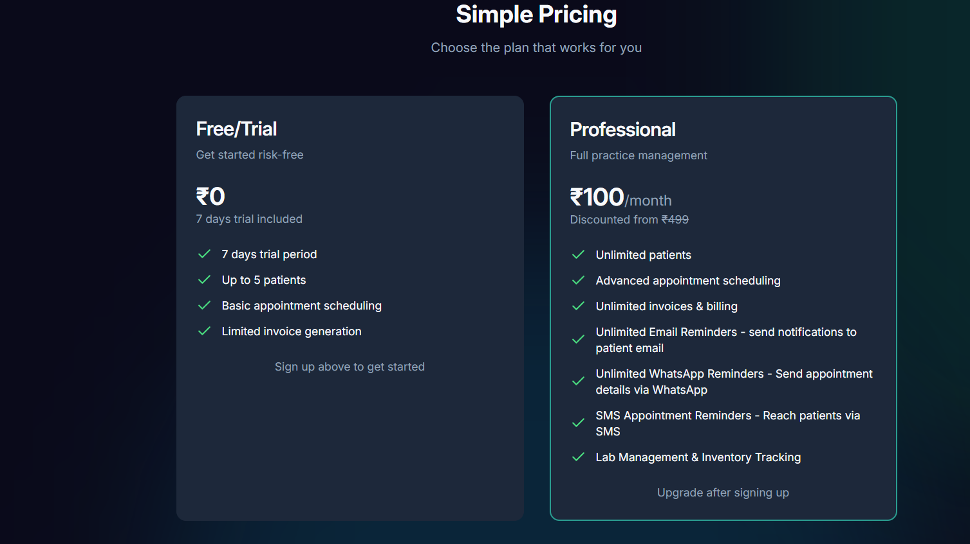

4) On left panel menu we need to add ‘Profile verification status’
View the current verification status of their profile.
Track the progress of their application reviewed by the BGM Team.
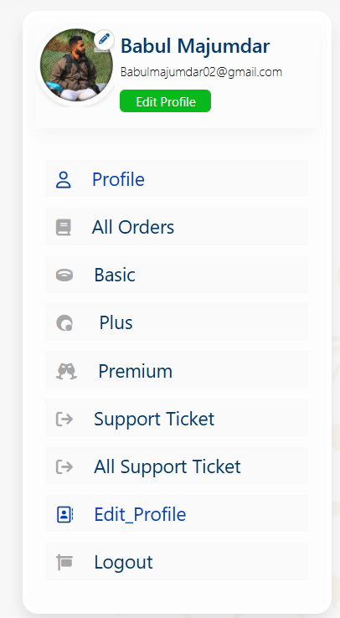
The Profile Verification Status section should allow users to track the progress of their profile verification by the BGM Team.
It should display:
- Current Application Status (e.g., Submitted, Under Review, Verification in Progress, Approved, Rejected, or Additional Information Required).
- Progress Tracker showing the current stage of the verification process.
- Date and Time of the latest status update.
- Remarks/Comments from the BGM Team, if applicable.
- Estimated Completion Time (if available).
- Notification when the profile is approved or if any additional information/documents are required.
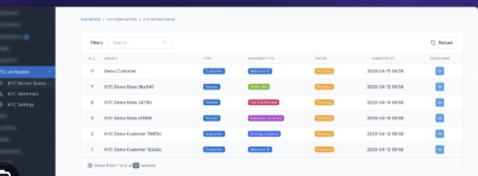

5) Profile Completion Status & Progress Calculation
- When a user starts the application, all section icons (✓) should be grey, indicating that no information has been submitted yet.
- Once a section is completed and submitted successfully, the corresponding tick icon should automatically change from grey to green.
- The Profile Setup progress meter on the right panel should automatically calculate and update the completion percentage based on the completed sections.
Once a user has submitted their profile/application, they should not be allowed to edit it directly.
If the user wishes to make any changes after the final submission:
- The user must click the "Request Profile Edit" button.
- An edit request will be sent to the Admin Panel for approval.
- The profile will remain read-only until the request is approved.
- The Admin can Approve or Reject the edit request.
- Once approved, the user will receive a notification, and the profile will be unlocked for editing for a specified period (or until the changes are resubmitted).
Admin Panel Features:
- View all profile edit requests.
- Approve or Reject requests.
- Add remarks/comments for the user.
- View edit request history with date, time, and status.
6) After submitting
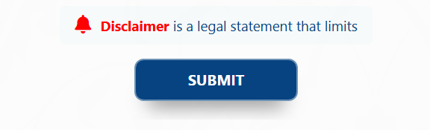
Profile Submission Confirmation Popup
After the user clicks the Submit button and the profile is successfully saved, a confirmation popup should be displayed.
Popup Title:
✅ Profile Submitted Successfully!
Popup Message:
Your profile has been saved successfully.
Please review your profile carefully. You will have 36 hours to make any changes or corrections.
After the 36-hour editing window expires, your profile will be automatically submitted to the BGM Team for verification, and no further changes will be allowed unless an Edit Request is approved by the administrator.
Buttons:
- Review My Profile (Primary Button)
- Go to Dashboard (Secondary Button)
Additional Note:
- Display a 36-hour countdown timer on the dashboard.
- During this period, the user can edit and resubmit their profile as many times as needed.
- Once the countdown reaches 0, the profile status will automatically change to "Under Verification", the profile will become read-only, and any future edits will require Admin approval.
Workflow
- User completes the profile and clicks Submit.
- A success popup is displayed.
- A 36-hour review/edit window begins.
- The user may edit and resubmit the profile during this period.
- After 36 hours, the profile is automatically sent to the BGM Team for verification.
- The profile is locked, and any further changes require an Edit Request approved by the Admin.
7) Information (i) Icon on Every Form
Every form and profile section should include an Information (ⓘ) icon next to the section title or relevant fields.
When the user clicks or hovers over the ⓘ icon, a tooltip or popup should display helpful guidance, including:
- What information is required.
- Why the information is needed.
- The accepted format (if applicable).
Example:
- Education Details ⓘ
- Employment Details ⓘ
8) Mandatory Fields
All mandatory fields should be clearly identified to ensure users complete the required information before proceeding.
Requirements:
- Display a red asterisk (*) next to all mandatory fields.
- Mandatory fields must be validated before the user can save or submit the form.
- If a required field is left blank, display a clear validation message, such as:
  - "This field is required."
  - "Please enter your Date of Birth."
- Highlight incomplete mandatory fields with a red border and an error message.
- Users should not be able to proceed to the next section or submit the application until all mandatory fields are completed.
- The profile completion percentage should only increase after all mandatory fields in a section have been successfully completed and saved.
- If any mandatory information is removed during editing, the section should be marked as Incomplete, and the profile completion percentage should be recalculated automatically.
9) Reference Contact (2 ref.)
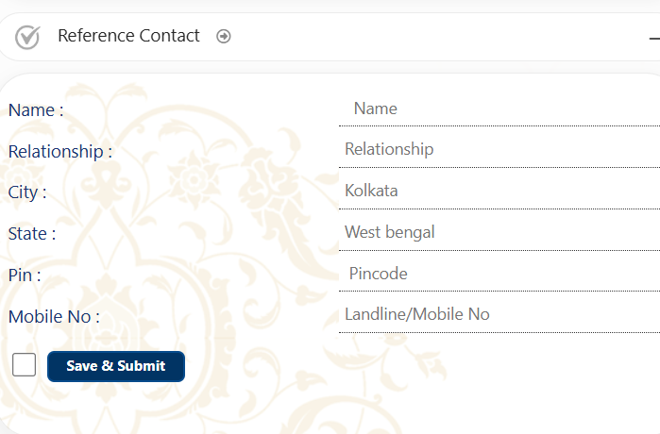
- Name *
- Relationship *
- City *
- State *
- PIN Code *
- Mobile Number *
- Email ID (Optional)
Reference Contact 2
- Name *
- Relationship *
- City *
- State *
- PIN Code *
- Mobile Number *
- Email ID (Optional)
At the bottom:
┌─────────────────────────────────────────────┐
│ Reference Contact 1 │
├─────────────────────────────────────────────┤
│ Name* [______________] │
│ Relationship* [______________] │
│ City* [______________] │
│ State* [______________] │
│ PIN Code* [______________] │
│ Mobile No.* [______________] │
│ Email [______________] │
└─────────────────────────────────────────────┘

┌─────────────────────────────────────────────┐
│ Reference Contact 2 │
├─────────────────────────────────────────────┤
│ Name* [______________] │
│ Relationship* [______________] │
│ City* [______________] │
│ State* [______________] │
│ PIN Code* [______________] │
│ Mobile No.* [______________] │
│ Email [______________] │
└─────────────────────────────────────────────┘

☐ I confirm that both references have agreed to
be contacted for verification.

[ Save & Submit ]

- Testimonials Section
like
